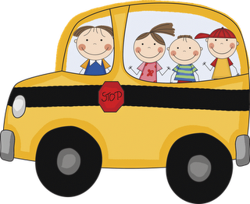

**REMINDERS**

* If you have not paid the classroom fee, please do so as soon as possible ($50.00.) Thank you parents who have already done so.
* Talent Show dress rehearsal will be this Wednesday, Sept. 24th. Please make sure to send costume, music, and props that will be used on the Kermes! So exciting!

**Birthdays**

Daniel Patino (Sept. 25th)!

**Important Dates**

**Sept. 24th**: Chuck –E- Cheese Night 3-9 pm.

**Sept. 25th:** National Good Neighbor Day!

**Sept: 26th:** Happy birthday Johnny Appleseed!

**Sept. 27th:** School Kermes (4pm- 9pm)

**Star of the Week**

Kevin Calderon

(Sept. 25th at 2:00 pm)

**Math**

* Number sense
* Measurement
* Geometry

Students will understand: whole numbers have a specific order. A geometric figure can be identified by counting the numbers of sides and angles, geometric shapes can be sorted by attributes, and shapes have an inside and outside.

**Peek at Our Week**

* **Phonemic Awareness** (train our ears to listen to sounds and train our lips to say sounds) : Rhyming and beginning sounds
* **Comprehension Strategy**: Noticing detail
* Previewing the ABC’s
* **Oral Language**: Using describing words (adjectives).
* **Writing**: Shared, interactive and independently.

**Religion:** Praying the Rosary

**Science/Social Studies:** in science studies will continue to look at living and nonliving things. In social studies we will be learning about John Chapman “Johnny Appleseed”, fall changes and the world around us.

