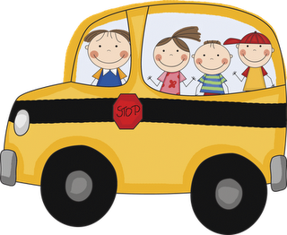

**Calendar**

* **Oct. 29th:** Title 1 meeting at 8:00am.
* **Oct. 30th:** Picture Day! All students **must** wear formal with sweater.
* **Oct. 31st:** HappyHalloween! Halloween parade will begin by 8:00 am. Early Dismissal at 12:30 pm. If you are able to come and help supervise your child, you are more than welcome to come and join us. You may also take your child home earlier than 12:30 pm if you wish to do so.

**Talent Show**

* Kindergarten will be dancing to “La Bamba” by Ritchie Valens. Boys will be wearing white t-shirt with jeans and black tennis shoes. Girls will be wearing white shirt with a poodle skirt, scarf around the neck, black dress shoes (no heels) and hair will be up on a pony tail.
* Parents with girls in kindergarten, it asked to please if possible to put your child’s hair up in a pony tail, braid or bun. If you suspect that your child may have lice please make sure to inform us and take the appropriate steps get rid of them. It’s not to alarm anyone but just a reminder to think about all of the students in kinder. Thank you!

**Peek at our Week**

**Language Arts:**

**Phonemic awareness**: blending/segmenting onsite and rime.

**Phonics:** beginning sound /t/ and initial consonant T,t.

**High Frequency Word**: my

**Comprehension Strategy**: Predict/Infer, Summarize

**Comprehension Skill:** Sequence of Events and inferences: making predictions

**Writing**: Shared, interactive, and independent

**Vocabulary Words**: Color words (red, yellow, blue, black, pink, purple, brown, black, green, orange, and gray.)

**Math:** creating addition problems, pattern blocks, patterns,

and double facts. **Written assessment: Tuesday, Oct. 28th.**

**Science:** Pumpkin Investigation

**Religion:** Celebrating All Hollow’s Eve

**Reminders**

* Please make sure to send your child’s PE uniform to change into after the

Halloween parade. Do not want

their Halloween costumes

to get all dirty.

Thank you!

**Birthdays!**

* Arianna Verduzco

(October 28th)

* Jaslene Meza

(October 28th)

