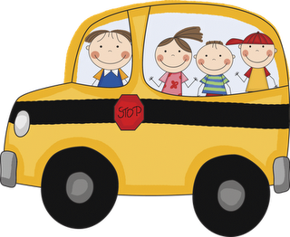

**Calendar**

* **Oct. 20th-24th:** Red Ribbon Week!
* **Oct. 21st:** Under Family Farm Field Trip
* **Oct. 23rd:** Star of the Week, “Emma Meehan”
* **Oct.** 23rd: Fire burn assembly!

**Red Ribbon Week Activities**

* **Monday**: Red Ribbon Week assembly
* **Tuesday**: Red Ribbon Week-wear red
* **Wednesday**: Team up against drugs- wear favorite team jersey with jeans and tennis shoes.
* **Thursday**: Put a sock on drugs- wear your craziest socks with your uniform.
* **Friday**: Share a red snack with your school family (need a family to donate red snacks. Please see me or send me a note)

Please show your crusader pride and join us in this week’s activities. If you have any question or concerns, please come speak to me.

**Peek at our Week**

**Language Arts:**

**Phonemic awareness**: beginning sound/words in oral sentence.

**Phonics:** beginning sound /r/ and initial consonant R,r.

**High Frequency Word**: I, see (Review).

**Comprehension Strategy**: Predict/Infer, Summarize

**Comprehension Skill:** Sequence of Events and inferences: making predictions

**Writing**: Shared, interactive, and independent

**Vocabulary Words**: Color words (red, yellow, blue, black, pink, purple, brown, black, green, orange, and gray.)

**Math:** creating addition problems, pattern blocks, patterns, and double

facts. **Written assessment on Thursday, Oct. 16th.**

**Science: Pumpkin Investigation**

**Religion:** Praying to Our Lady of the Holy Rosary. Please practice to pray the rosary as a family. Our Lady of Guadalupe will begin her journey beginning next. Each child will have the opportunity to have her visit their home and pray

**Reminders**

* Please remember to follow the school dress code. Take a moment to read the parent handbook and refresh yourself on what’s appropriate and what is not.

**Thank you!**

Thanks to all the parents for the your

continued support and involvement. For being on top of everything and doing your part. Makes

things much easier.

God Bless!

