

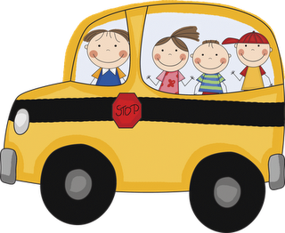

**Reminders**

* Read at least 20 mins. a day to your child.
* Fluency every day. Letter and sound recognition.
* Don’t forget to log into Mathletics.

**Calendar**

* **Nov. 12th:** Free dress for children how attended mass on Sunday.
* **Nov. 15th:** Talent Show “Oldies But Goodies”. Get ready to bring your chairs, comfy blankets and appetite to enjoy the show! Thank you Mrs. Calderon for taking the time to come in and showing the children the dance. God bless!

**Talent Show**

* Kindergarten will be dancing to “La Bamba” by Ritchie Valens. Boys will be wearing white t-shirt with jeans and black tennis shoes. Girls will be wearing white shirt with a poodle skirt (any color), scarf around the neck, black dress shoes (no heels) and hair will be up on a pony tail.
* Parents with girls in kindergarten, it asked to please if possible to put your child’s hair up in a pony tail, braid or bun. If you suspect that your child may have lice please make sure to inform us and take the appropriate steps get rid of them. It’s not to alarm anyone but just a reminder to think about all of the students in kinder. Thank you!

**Peek at Our Week**

**Language Arts:**

**Phonemic awareness**: blending/segmenting onsite and rime.

**Phonics:** beginning sound /n/ and initial consonant N,n.

**High frequency word** (review): I, like, see, my

**Strategy focus:** Summarize, Evaluate

**Comprehension skill:** Inferences: Drawing Conclusions and Story Structure: Characters and Setting

**Writing**: Shared, interactive, and independent

**Concept of print:** Capitalize first word in sentence; end punctuation; return sweep.

**Vocabulary skills:** Using action words (verbs) and order words.

**Writing skills:** Writing a grocery list, choosing a good title.

**Math:** creating addition problems, pattern blocks, patterns,

and double facts.**.**

**Science:** Life Cycle of a Pumpkin

**Religion:** Giving Thanks!

**Birthdays**

**November 19th:** Mrs. Pereyra **November25th:** Anthony Vanegas

**November 27th:** Nathan Rodriguez

