

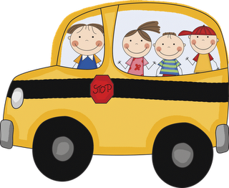

**Birthdays**

Alan Ceja

(December 18th)

**Reminders**

* Fluency every night.
* Read at least 20 mins. every night.
* Please continue to bring in your bag of candy for the school posada!

**Save the Dates!**

* **Dec. 18th:** Class Christmas party.Early dismissal 12:30 pm. Donations of cookie, cupcakes and donuts are welcome.
* **Dec. 19th:** Christmas break begins
* **January 7th:** Classes resume!

**Calendar**

* **Dec. 15th:** SchoolChristmas concert at 7:30 pm.
* **Dec.** 16th: School will begin at 8:30 am (late start.)
* **Dec.** 18th: Gingerbread house. Parent volunteers are needed to help out.
* **Dec. 18th:** Classroom Christmas party. Early dismissal at 12:30. Please make proper arrangements for your child to be picked up.

**Peek at our Week!**

* **Language Arts:**

**Phonemic Awareness:** blending/segmenting onset and rime and blending phonemes. **Concept of Print:**  word spacing and matching spoken words to print. **Writing Skills:** writing an elf contract

* **Math**: Geometry (covering a design with pattern blocks), Number sense (ordering numbers to 20 and adding to a number) and mastering double facts.
* **Religion**: Celebrating Advent!
* **Art**: Christmas ornament.